Haskayne email signature guide

PC Users – Outlook Desktop App
Step 1
In Outlook, click “New email” at the top left-hand corner of your main screen.
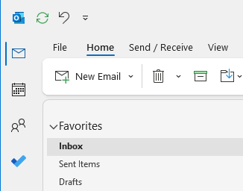

Step 2
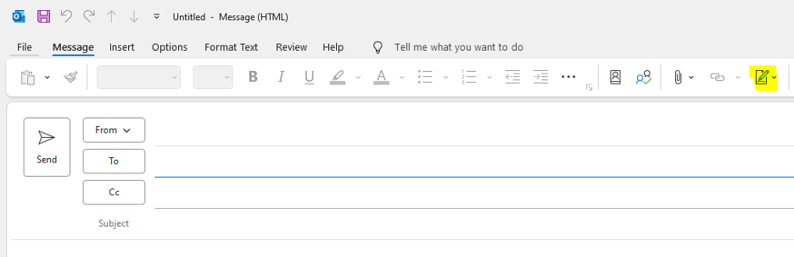
Tap on the “Signature” icon. And select “Signatures...” from the drop-down menu.

Step 3
A new window will pop up. Select “New” from the top right. Give your signature a name.
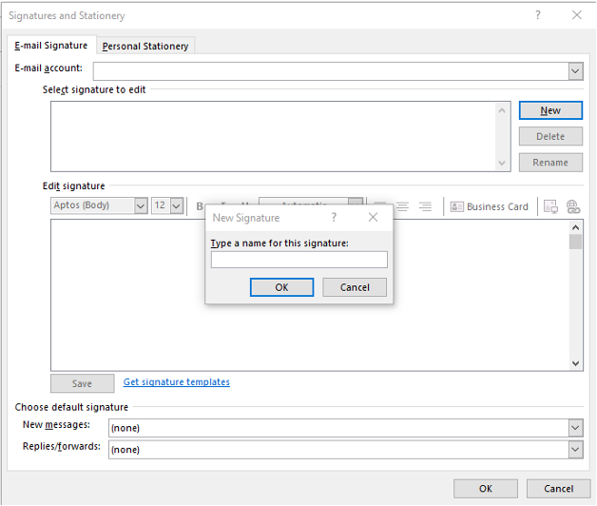

Step 4
Copy the email signature below and paste it into the box below your signature name. Please do not change the size of the logo once you paste it into Outlook.
BEGINNING OF SIGNATURE ––––––––––––––––––––––––––––––––––––––––––––––––––––––––––

First Last, degree
Job title
Haskayne School of Business | Department
2500 University Drive NW, Calgary, AB, Canada T2N 1N4

T 000-000-0000
C 000-000-0000
haskayne.ucalgary.ca


END OF SIGNATURE –––––––––––––––––––––––––––––––––––––––––––––––––––––––––––––––––

Step 5
Replace all template information with your personal details.
Double check that your font and colour usage are correct:
- Font name: Aptos
- Font size: 10pt
- Colour:
  - Orange: R=255 G=103 B=31
  - Dark grey: R=109 G=110 B=113
Reminder: Ensure you select “Default” for New messages.
Once all updates have been made, select the “OK” button.
Step 6
Congratulations, you have created your new email signature! To test that it works properly, please open a new email and ensure your signature shows up and is correct.

Outlook Mobile App
Step 1
In the Outlook mobile app, find an email you have already sent with your updated signature from the desktop app. Highlight it and copy it.

Step 2
Tap your profile photo in the top left-hand corner. Then tap on the settings icon in the bottom left-hand corner.
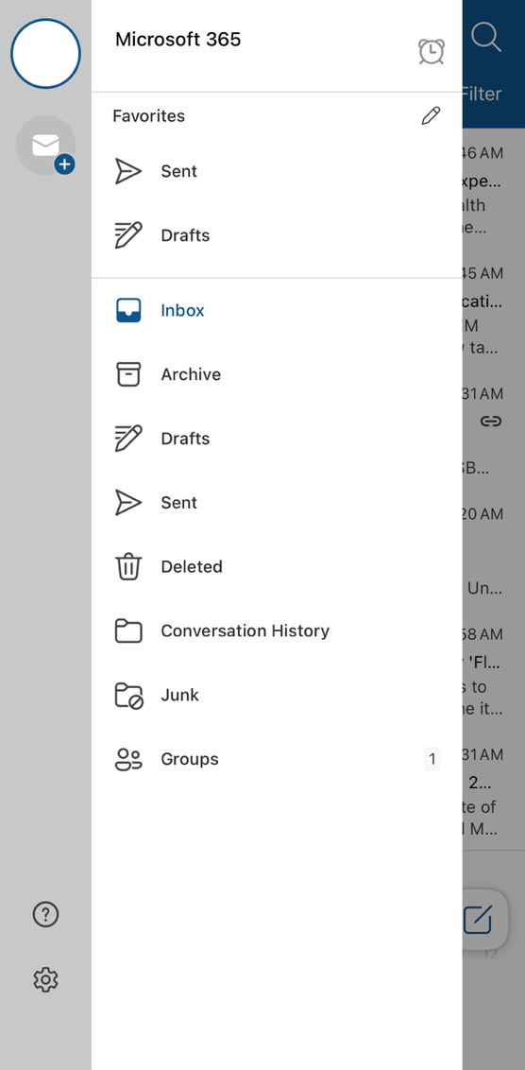

Step 3
Tap on “Signature” from the navigation and paste your signature. If it pastes the logo twice, remove the smaller one, tap on the large one, and “Resize”. Resize your logo accordingly.
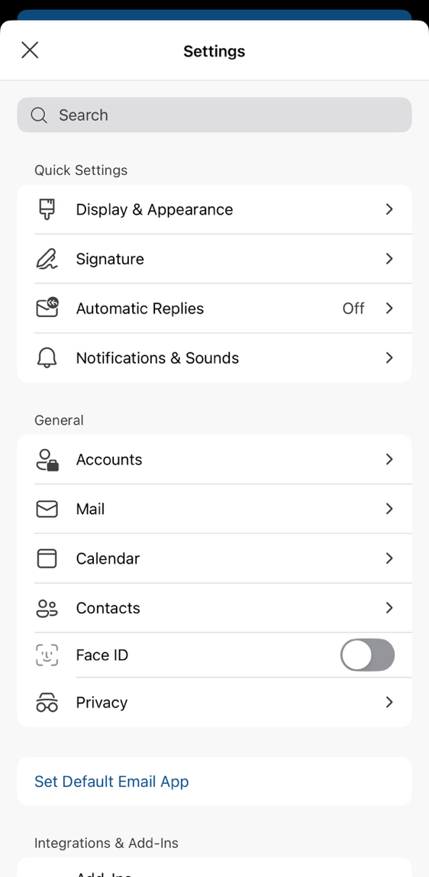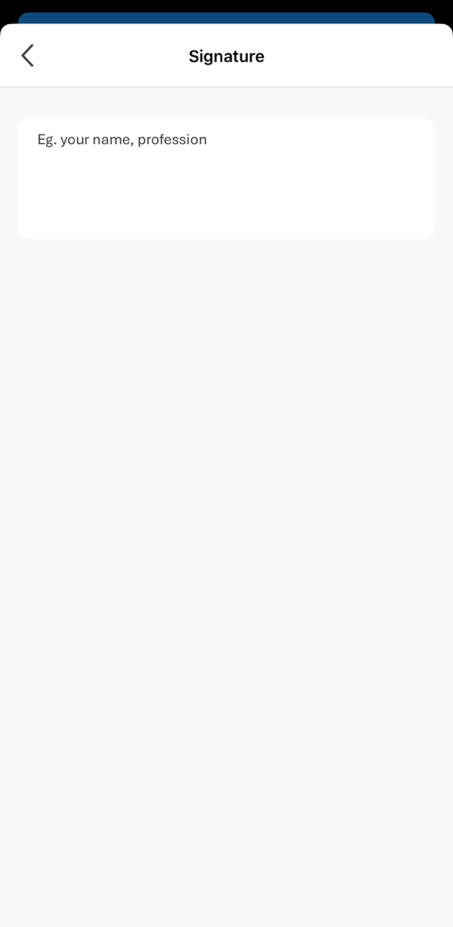

Step 4
Congratulations, you have created your new email signature! To test that it works properly, please open a new email and ensure your signature shows up and is correct.

Apple Users – Outlook Desktop App
Step 1
In Outlook, click “New Mail” at the top left-hand corner of your main screen.
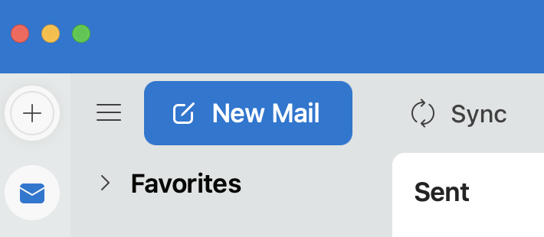

Step 2
Select the “Signature” button on the top bar and select “Manage Signatures” from the drop down menu.
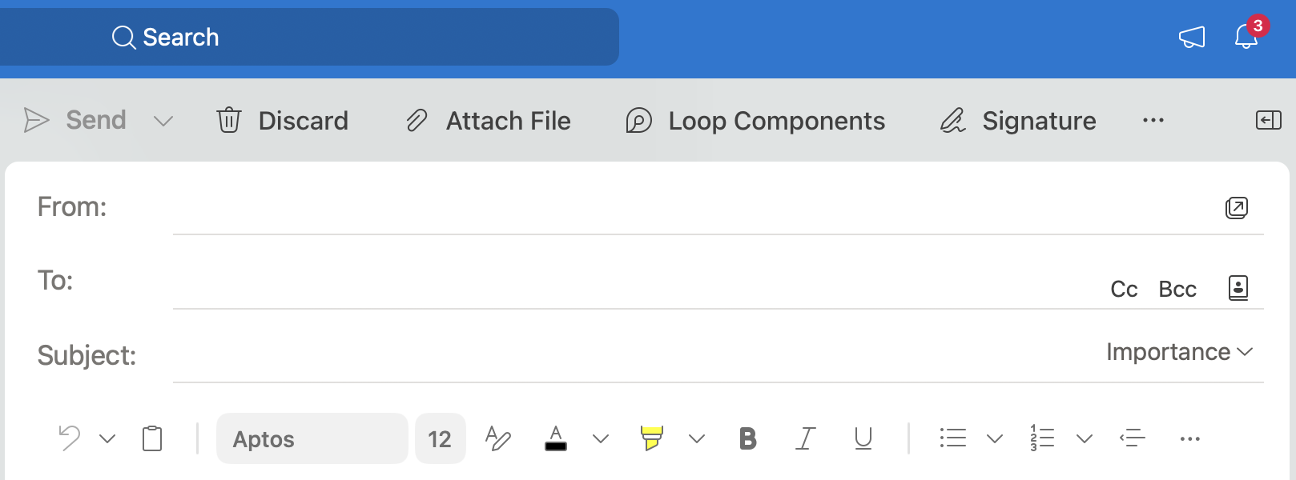

Step 3
A new window will pop up. Select the plus button. Another window will pop up. Give your signature a name.
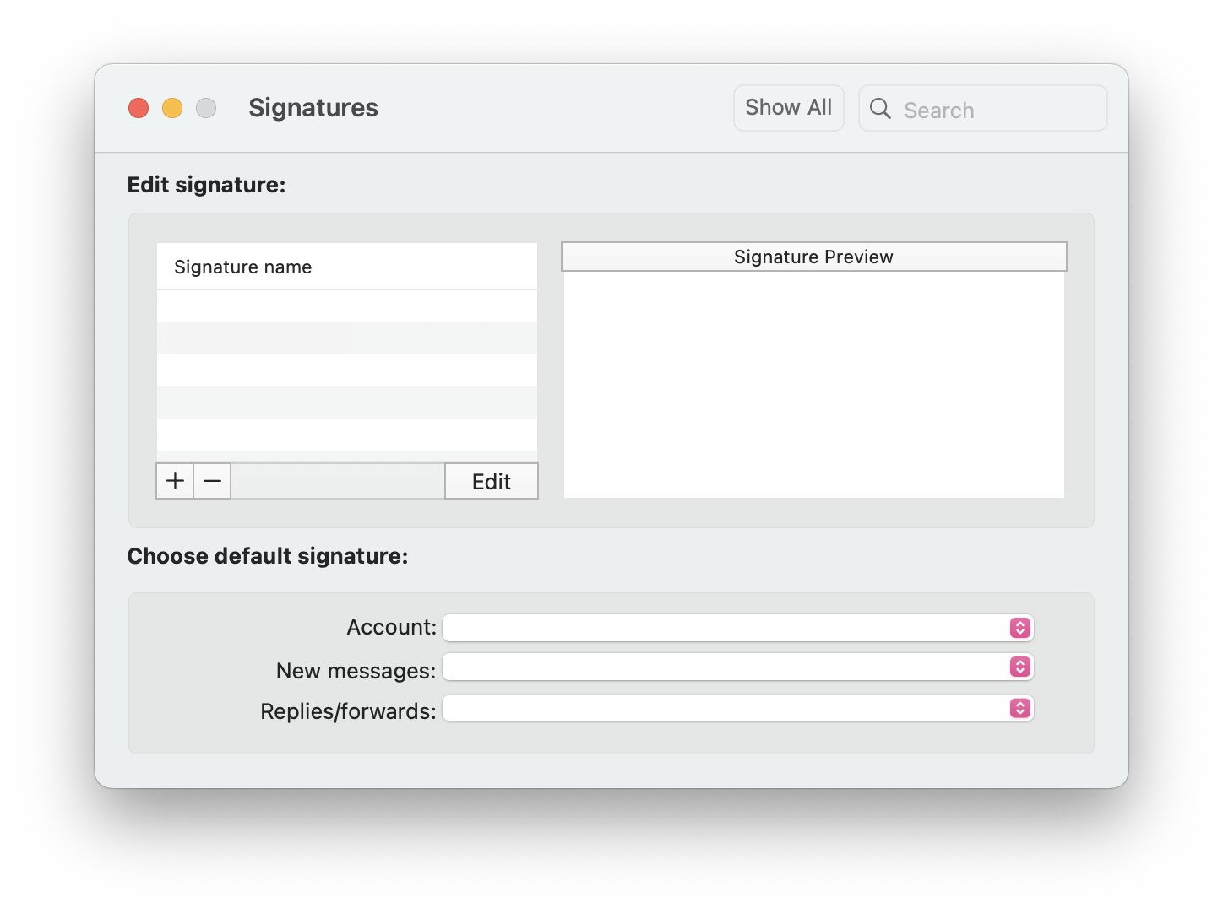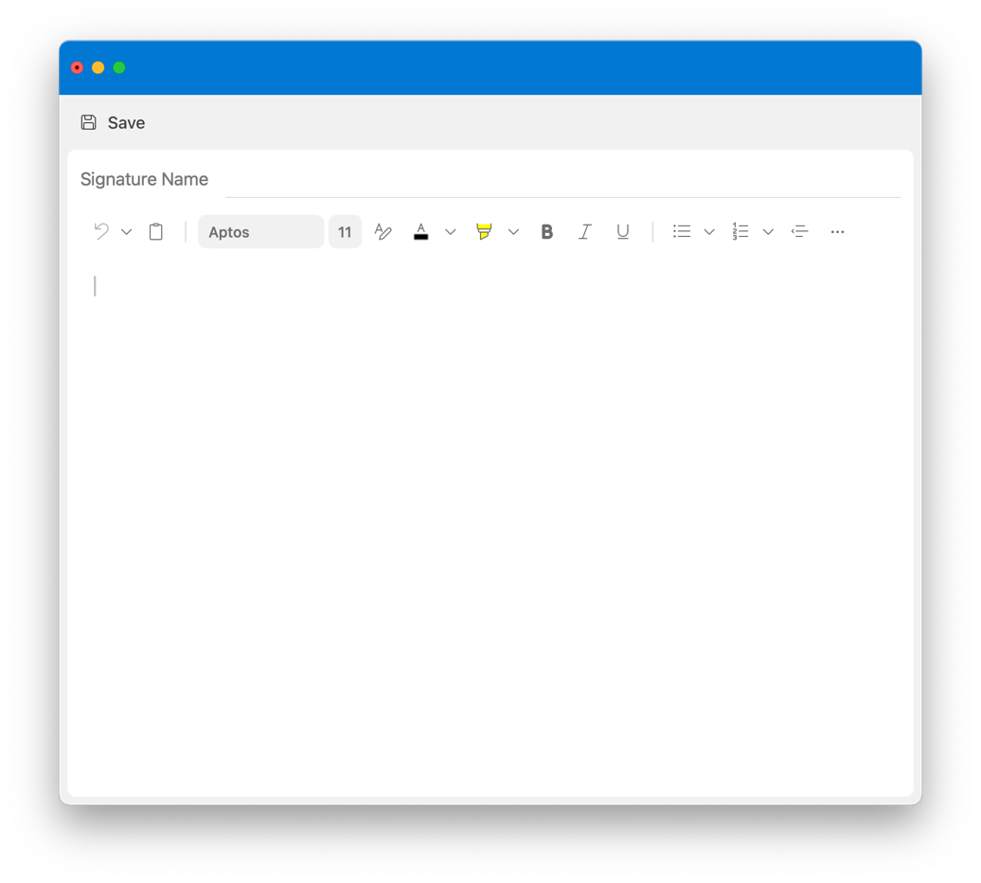
Step 4
Copy the email signature below and paste it into the box below your signature name. Please do not change the size of the logo once you paste it into Outlook.
BEGINNING OF SIGNATURE ––––––––––––––––––––––––––––––––––––––––––––––––––––––––––

First Last, degree
Job title
Haskayne School of Business | Department
2500 University Drive NW, Calgary, AB, Canada T2N 1N4

T 000-000-0000
C 000-000-0000
haskayne.ucalgary.ca

END OF SIGNATURE –––––––––––––––––––––––––––––––––––––––––––––––––––––––––––––––––

Step 5
Replace all information with your personal details.
Double check that your font and colour usage is correct:
- Font name: Aptos
- Font size: 10pt
- Colour:
  - Orange: R=255 G=103 B=31
  - Dark grey: R=109 G=110 B=113
Press the “Save” button before closing.
Reminder: Ensure you select your new signature as the default for New messages and Replies/forwards.
Once all updates have been made, you can close the tab.
Step 6
Congratulations, you have created your new email signature! To test that it works properly, please open a new email and ensure your signature shows up and is correct.

