D2L Quiz - Student Tip Sheet
Before You Begin
- Before you begin the Quiz, please ensure you are in a quiet, distraction free environment.
- Ensure your laptop is plugged in, your device is fully charged, and your internet connection is reliable.
- Ensure you have a clear workspace, ready with a pen and paper for jotting down notes or doing calculations.
- Once you begin the Quiz, you must finish it in one sitting. Please be sure you are ready before starting the Quiz.
Taking the Quiz
- To take the Quiz, navigate to your D2L course page, and click on the “Assessments” tab, then select “Quizzes”:
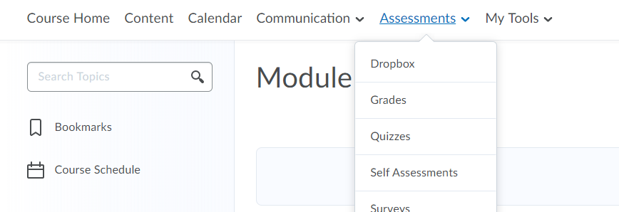
- Once you have selected the Quiz and Started the Quiz, your time will begin.

- All questions will be automatically saved as you go, when you click on to the next question.
- To get to the next question, simply press “Tab” or use your mouse to click to the next question.
- A check mark in the Navigation pane indicates your question is saved, but not submitted.
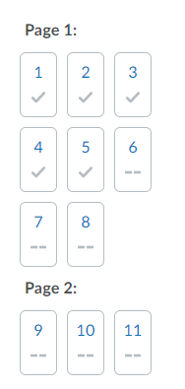
- When you are finished your Quiz, be sure to fully submit your Quiz by clicking the “Submit Quiz” button at the bottom of the page, and confirm your submission:
Technical Support
- If you have any internet connectivity issues during your Quiz, D2L should recognize this and allow you back in the Quiz immediately following your blip. If this is not the case, please connect with your Instructor immediately.
- If you have any technical issues while taking the Quiz, please take a screen-shot and send it to your Instructor immediately.

