How to self-enroll in groups (instructions for students)
- In your D2L course, navigate to Communication from the navigation bar along the top and select Groups.
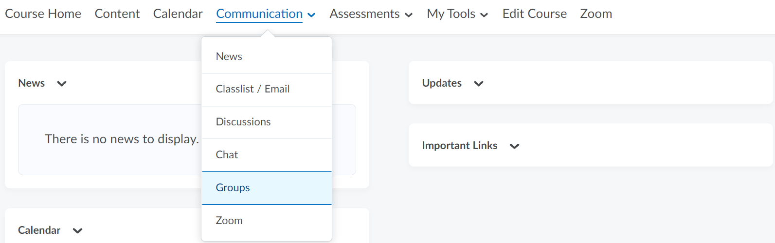

- Click on View Available Groups.
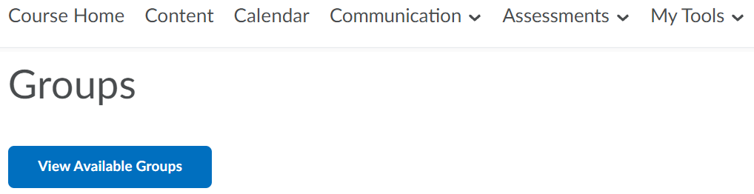

- Click Join Group
  - Note: if you pre-signed up for groups in class, join the group that you signed up for. You can typically find a copy of this signup on the course’s D2L site.
- Note: once you’ve chosen your group, you will not be able to un-enroll yourself, so ensure you select the correct group the first time!

- You will then see a confirmation page that looks like this: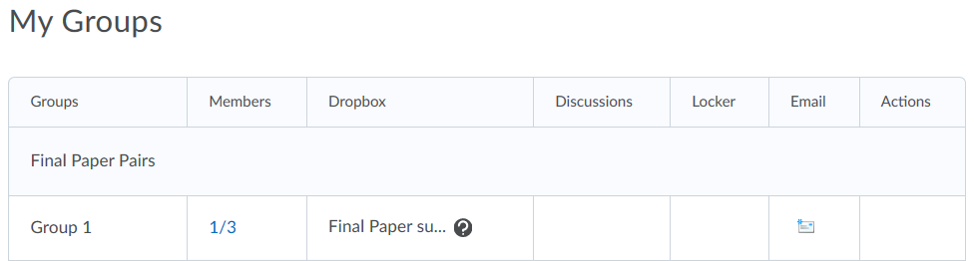

- You have successfully self-enrolled in your group.

